**ROTARY CLUB**

**Chippy Firewalk**

**Information Pack**

**Chippy Firewalk, Town Hall, High St, Chipping Norton on Friday 28th March 2025 Event kindly sponsored by L A Lockhart Plant Hire Ltd**

# Chippy Firewalk – 28th March 2025

# *Thanks For Your Interest in the Chippy Firewalk*

This note will help you decide whether your team should sign up to take part in the challenge and provide you with useful information about the Firewalk. Below you will find:

* A Firewalk overview
* Details of the event
* Answers to frequently asked questions

If you have any further questions, please contact [fundraising@MyVision.org.uk](mailto:fundraising@MyVision.org.uk).

***WHAT IS IT?*** Firewalking is stepping barefoot over a bed of hot embers. It is practised by cultures in many parts of the world, as a rite of passage, a test of courage, or a test of faith. It is safe because the foot does not touch the hot surface long enough to burn, and embers are poor conductors of heat. Adult walkers (16 and above) are trained by [BLAZE](http://www.blazefirewalking.com/) whilst the bed of embers is prepared. Each walker is escorted across the embers with all the necessary safety precautions. Once a walker has crossed the embers their walk is complete, and they receive their certificate.

***IS FIREWALKING SAFE?*** Blaze has an impeccable professional record and they will get you through the event in complete safety. They have been running firewalks for over 20 years, their safety checks and procedures are fine-tuned, and the team organising the walk is extremely experienced. Not one person attending their motivational training has refused the opportunity to firewalk.

***WHY SHOULD I DO IT?*** This will be an inspirational experience for your team, allowing you all to raise money for your good cause. You will feel motivated, empowered, and inspired to face your fears. Given the type of event, donors often offer higher sponsorship than you would get for a normal sponsored walk or sports challenge, so it’s a fantastic way to support **YOUR CHARITY OR GOOD CAUSE**.

***DO I NEED TO DO ANY PREPARATION?*** No! On the evening of the event, you will take part in a motivational, fear-busting seminar that will equip you with the mental strength to walk across the fire bed, unharmed.

# Event Details

The Rotary Club is the organiser. The Firewalk is on the High Street, outside the Town Hall, on Friday 28th March 2025. The event will begin at about 6:30 pm with some children’s entertainment, and the walk itself begins around 8:30 pm. All participating firewalkers and teams must register in the Town Hall from 6:30pm and, importantly, **must** undergo the training seminar from the beginning, commencing at 7:00pm.

## ROTARY CLUB

The training is based around proven motivational methods. It does not involve any element of hypnosis, spiritual training, chanting, “brainwashing‟, or any similar methodologies.

It is, however, tremendous fun! Participants gain: Increased confidence and self-esteem, Released fears and doubts, A breakthrough from limiting beliefs and conditioning, A transformation of fear into positive action, Lots of fun and laughter.

After the training seminar, your team will be led out to the fire, and given the opportunity, one by one, to walk along the 6 metre (20ft) fire lane. After everyone has completed their walk, the firewalkers will receive certificates of achievement.

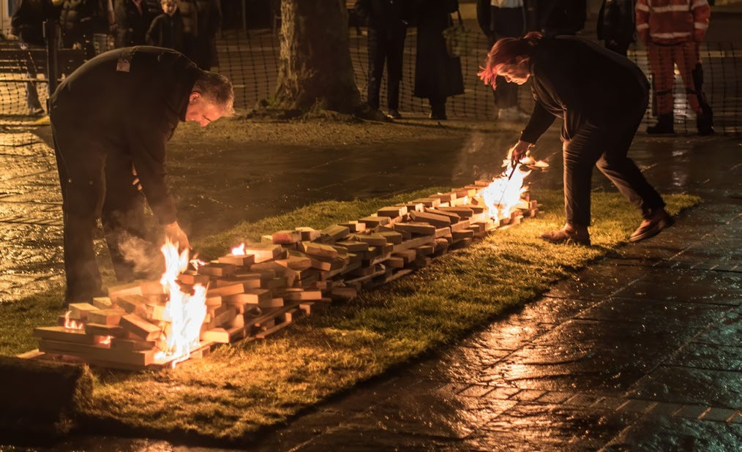Drugs or alcohol are forbidden before or during the event. Firewalkers must not be under the influence of alcohol or drugs; the Blaze team will reject any participant suspected of drugs or alcohol.

Firewalkers and teams are encouraged to bring supporters and spectators. Children’s entertainment will be provided during the walkers’ training and refreshments will be available. No spectators, videos, cameras or audio equipment are allowed in the training seminar.

Rotary will be taking a video, and photos, at the event to record your fantastic achievements, but we will respect your privacy. Photographers and videographers are clearly identified so let them know if you do not want to be in photographs. After final editing, the video will be circulated to all teams.

***NOTE:*** *Exact timings will be confirmed nearer to the event. Registration will begin at 6:30pm, team training begins at 7:00pm, the fire will be lit at around 8:00pm, and the firewalk itself will take place soon after 8:30pm. Entertainment, food and drink available from about 6:30pm.*

**ROTARY CLUB**

# FAQs

***WHAT KIND OF PEOPLE FIREWALK?*** People from all backgrounds have taken part in firewalks. Many are seeking to make positive changes in their life or want to take on a different kind of challenge for charity.

***DO I HAVE TO WALK IF I SIGN UP NOW?*** No, but places are filling up fast. At any time, you may decide not to walk, and withdraw. However, registration fees are non-refundable, but no one will be **made** to complete the firewalk if they do not wish to do so.

***IS IT REAL FIRE; WHAT DO YOU BURN?*** Yes, the fire is real and under strict control. Blaze burns wood: a combination of pine, ash and oak, broken down into a smooth red-hot path 20ft long by 2ft wide.

***DOES THE FIREWALK HURT?*** Surprisingly enough, everyone’s firewalking experience is unique to themselves. There are obvious physical reasons why firewalking is possible. These will be explained during the training. The hardest thing to overcome is the fear of taking the first step, as it is a new experience!

***WHAT DOES IT FEEL LIKE?*** Opinions vary. A few people cannot remember having any physical sensation at all about the experience. Some report that it was freezing cold “like walking on crunchy snow”, but others perceive it to be hot.

***DO I HAVE TO RUN?*** Not at all; running pushes your feet deeper into the embers. A quick walking pace is enough.

***DO I WALK ON A FLAMING FIRE?*** No, you walk on the fire bed itself. By the time you come out of the training seminar the fire will have burnt down to embers. If there are any flames, they will be down the sides of the fire lane.

***WHAT HAPPENS DURING THE TRAINING?*** Amongst other things, training examines the mind/body connection, explores comfort zones and expands them to overcome limiting beliefs. It culminates in the option to walk on fire.

***ARE THERE AGE LIMITS?*** The minimum age is 16 years. There is no upper age limit!

***WHAT HAPPENS IF IT RAINS?*** The Blaze fire team get wet! Provisions are made for all types of weather conditions and if the wood is kept dry prior to lighting, the event will go ahead.

***WHAT’S THE BEST THING TO WEAR ON THE NIGHT?*** There are no specific requirements for types of clothing but normal casual clothing is best. Just roll up the bottom of your trousers, so they don’t get dirty. Remove tights and stockings before the walk itself and bring wet wipes as your feet will be sooty from walking on the fire bed, or your socks and shoes will get filthy! Please wait until after the firewalk to have your pedicure. Do not use creams and/or foot sprays on the day of the firewalk. Nail varnish on toes is safe - there is no need to remove it.

If you have any further questions, please email [fundraising@MyVision.org.uk](mailto:fundraising@MyVision.org.uk). We will respond as quickly as we can.



**Club of Witney**

*Thank you from all at Rotary.*